Name: (print)__________________________ T.A. Name_____________________

Student #:______________________ Section # (see below)_____________

Exam 1
CEM 251 – Spring 2016
(Dr. Walker)
-Version A-
Page # | Points
1 |  | /07
2 |  | /14
3 |  | /11
4 |  | /17
5 |  | /08
6 |  | /16
7 |  | /18
8 |  | /09
 |  | /100
NAME | SEC.# | DAY/TIME | ROOM
Gayanthi Attanayake | 01 | Monday, 10:20-11:10 | 323
Gayanthi Attanayake | 02 | Monday, 11:30-12:20 | 085
Evert Njomen | 03 | Tuesday, 8:00-8:50 | 085
Evert Njomen | 04 | Tuesday, 9:10-10:00 | 085
Tyler Walter | 05 | Tuesday, 9:10-10:00 | 127
Gayanthi Attanayake | 06 | Wednesday, 10:20-11:10 | 323
Evert Njomen | 07 | Wednesday, 11:30-12:20 | 085
Tyler Walter | 08 | Thursday, 9:10-10:00 | 085
Prakash Shee | 09 | Thursday, 1:50-2:40 | 085
Tyler Walter | 10 | Friday, 10:20-11:10 | 127
Prakash Shee | 11 | Friday, 11:30-12:20 | 085
Prakash Shee | 12 | Friday, 12:40-1:30 | 085
 Attanayake Shee Njomen Walter

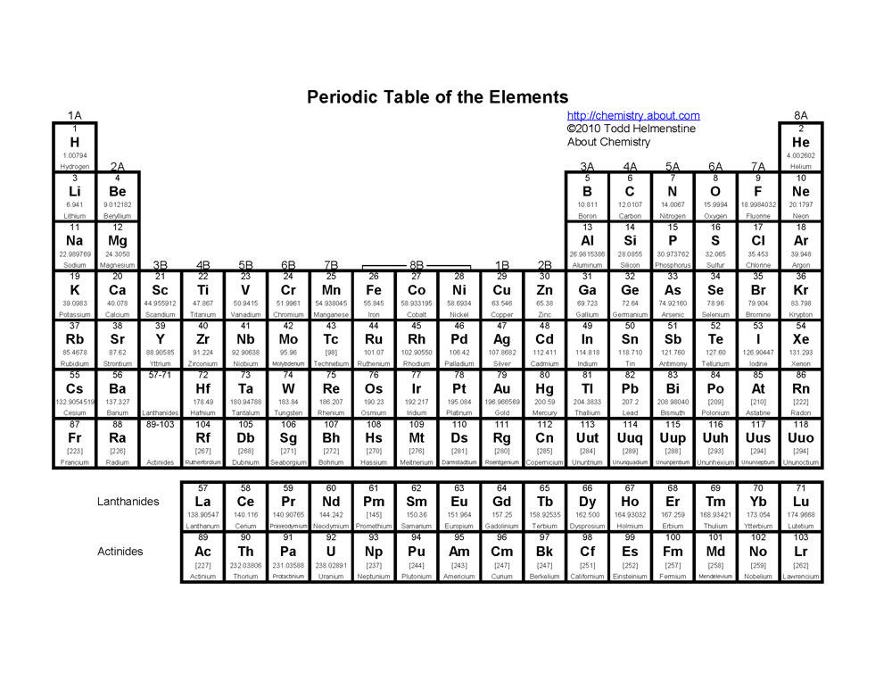
1) How many total electrons does a neutral atom of each element have? (Periodic Table above) (3 pts)
Aluminum Potassium (K) Argon

2) Give the ground-state electron configuration of each element. Use () and () arrows to show electrons when they are paired. CIRCLE THE VALENCE ELECTRONS (4 pts)

Magnesium (Mg) Chlorine (Cl)

CIRCLE THE VALENCE ELECTRONS ABOVE

3) CLEARLY draw all of the valence lone pair electrons () (as large as these) on the structure below?
(4 pts)

4) The compound above has...? (2 pts)
π-bonds

5) Calculate the formal charge on the atoms indicated. All electron pairs are shown. If none, write 0 in the box. (5 pts)

6) What is the molecular orbital hybridization, ie, sp^{x}, of the indicated atom? (3 pts)

7) How many hydrogens (hidden in the skeletal drawing) are bonded to the atom indicated? If none, write 0 in the box. (3 pts)

8) Arrange the following in order of increasing boiling point from 1 (LOWEST b.p) to 4 (HIGHEST b.p.)
(4 pts)

9) Draw a resonance structure where the C-atom (indicated with arrow) has a formal charge and the N-atom is neutral. must use arrows to show movement of electrons in structure at the left (2 pts, NO PARTIAL CREDIT)

10) For credit, must use arrows to show movement of electrons in structure at the left.
Draw a resonance structure that has a formal charge on the Oxygen and no charge on any other atom. (2 pts, NO PARTIAL CREDIT)

11) Rank compounds A through C from least to most acidic. (3 pts)

12) Draw ONE arrow in the box to indicate the favored direction of the acid/base reaction at equilibrium. (2 pts)
 | + |  |  |  | +
Ka = 10⁻²⁵ |  |  |  |  |  | Ka = 10⁻³⁸

13) Provide the IUPAC name for the compounds. NO COMMON NAME(S) for SUBSTITUENT(S)
(3 pts)

(3 pts)

14) Provide the IUPAC name for the compound. USE COMMON NAME(S) for SUBSTITUENT(S)

(3 pts)

(3 pts)

15) Circle the compound that has the most acidic proton (boxed). (8 pts)
Draw the conjugate base of each acid in the box below it.
If the conjugate base can form a resonance structure (without violating the octet rule), draw a resonance structure in the box below it.
If no resonance structure of the conjugate base can be drawn, then draw an X in the box.

16) Draw the structure. (3 pts)

cis-1-ethyl-2-neopentylcycloPENTane

17) Draw the ring-flipped conformation of the chair, at left, onto the template at the right. Circle the MOST STABLE conformation below. (NO PARTIAL CREDIT) (3 pts)

18) Convert the "flat" representation of the cyclohexane molecule (at left) to the chair conformation templates (at right). Circle the MOST STABLE (i.e., lowest energy) conformation below.

Numbers 1 and 2 are added for orientation only, not for naming the compounds. (NO PARTIAL CREDIT) (4 pts)

19) Draw a dot () (this size) on the chirality center(s) in each compound. Write the total number of center(s) found in the box. If none, then write 0 in the box. (NO PARTIAL CREDIT) (3 pts)

20) Assign R or S configuration to the chiral center(s). IF NEITHER R or S, THEN WRITE AN 'X' IN THE BOX (3 pts)

21) Identify the following pairs as (I)dentical or (E)nantiomers. Place the appropriate letter in the box.
(2 pts) (NOTE: the atomic numbers and mass numbers are provided for hydrogen isotopes).

22) Draw the compound below with wedged () and/or dashed () lines to show the 3-D perspective drawing of the chirality centers below. (4 pts)

23) Identify whether the following molecules are (E)nantiomers, (I)dentical, (C)onstitutional Isomers, or (N)ot isomers. Place appropriate letter in the box. (3 pts)

24) Assign Cahn-Ingold-Prelog rankings (1 – 4) to the following substituents. (4 pts)
25) Fill-in the blank circles for A and B with appropriate numbers to obtain the stereoisomer indicated below the structure. (5 pts)

26) Given the following pKa values for the following compounds, CLEARLY CIRCLE the strongest conjugate base among (A – D). (2 pts)
pKa 38 | Ka = 10⁻¹⁸ | pKa 16 | Ka = 10⁻²⁵
A | B | C | D

27) Looking directly at carbon 2, draw the Newman projection of the following. Fill-in all of the boxes with the appropriate atom and/or group. (4 pts)

Functional Groups
A) Alkene | B) Ether
C) Alkyne | D) Amine
E) Arene | F) Ketone
G) Halide | H) Thiol
I)Alcohol | J) Aldehyde
K) Carboxylic Acid | L) Ester
M) Amide | N) Acid Halide

28) Using the Table above, write the letter that best describes the functional group indicated in an ovarian cancer drug, paclitaxel analog. (3 pts)

